Fast**National University of Computer & Emerging Sciences, Karachi  
Spring -2025 CS-Department  
Assignment- 2   
18th March, 2025**

|  |  |
| --- | --- |
| **Course Code: EE1005** | **Course Name: Digital Logic Design (DLD)** |
| **Instructor Name: Muhammad Rahim** | |
| **Date of Submission** | **23rd March, 2025** |

1. Write the Boolean expressions for the following logic circuits and simplify these expressions using Boolean algebra.

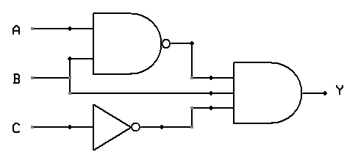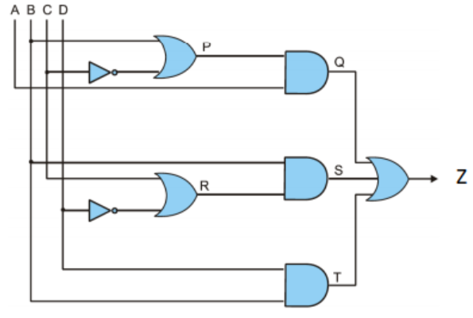

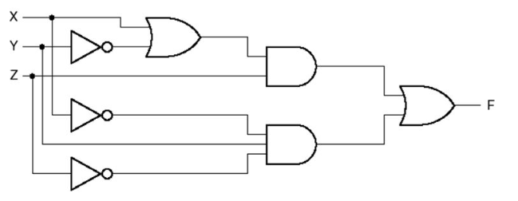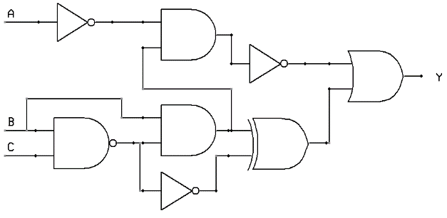

1. Consider the given expression, and simplify it using Boolean algebra. Also, develop the truth table and circuit of simplified form**.**

https://lh7-rt.googleusercontent.com/docsz/AD_4nXclWWX5HQNBFThUOmsCk6jfM0SPZe3e5ogJCL7Vqkor6AuWl7HfM6epwLj-h-IO37-chVJz5S5VBOrt_pmKwNHETgqrttTpRO_7aGlHGW9tMLeb0hz5hfOL3Y-i8UTg8nL7EK080Q?key=RhyDyAXosALpz4SWHJPYIqP3

1. Draw the circuit diagram of the following expression using NAND only, NOR only Gates

(i) A’B +B’A (ii) A’ B’ + AB

1. Draw the circuit Diagram of the following expressions using (Dual Symbols) NAND with Negative-OR  (i) (AB + C’)(DE + F’) (ii) ( A’ + B)( C + D’)( E + F)
2. Implement the following Boolean function F, using the two-level forms:

(a) AND-NOR, (b) OR-NAND (c) NAND –NAND (d) NOR_NOR logic diagrams

F ( A, B, C, D) = Σ(0,1,2,8,9,12) ; d (A, B, C, D) = Σ (3, 4, 10,11)

1. Design a combinational circuit with three inputs and one output. The output is equal to logic 1 when the binary value of the input is less than 3 AND the output is logic 0 otherwise.
2. Using a Karnaugh map convert the standard POS expression



into a:

(i) Minimum POS expression (ii) Standard SOP expression

(iii) Minimum SOP expression

1. Use a Karnaugh map to find the minimum POS for each expression:



1. Convert each of the following POS expressions to minimum SOP expressions using a Karnaugh map:



1. Simplify the following Boolean function F together with the don't-care conditions d; then express the simplified function in minimum SOP and minimum POS.

(a) F(A, B, C, D) = Σ (0,6,8, 13, 14) ; d (A, B, C, D) = Σ (2, 4, 10)

(b) F(A, B, C, D) = Σ (I, 3, 5, 7, 9,15) ; d (A, B, C, D) = Σ (4, 6, 12, 13)